
LJ INSTITUTE OF COMPUTER APPLICATION
&
Master of Computer Application Sem 3
SOFTWARE PROJECT :-1

PROJECT REPORN ON
HOSPITAL MANAGEMENT SYSTEM

Under the Guidance of
Prof. AJAY CHAUHAN

GROUP NUMBER:-63
SUBMITTED BY:-

Div Roll No. | Enrollment No. | Name
D45 | 25004401110226 | Lakshit Suthar
D23 | 25004401110192 | Nirmeet Makwana
D48 | 25004401110 | Kishan Madlani

TABLE OF CONTENTS

Contents

TABLE OF CONTENTS 2
1. PROBLEM DEFINITION 3
2. OBJECTIVES 3
3. CORE COMPONENTS / MODULES 3
4. PROJECT PROFILE 5
5. NEED OF THE SYSTEM 5
6. SCOPE OF THE PROJECT 5
7. ADVANTAGES OF HOSPITAL MANAGEMENT SYSTEM 6
8. LIMITATIONS OF HOSPITAL MANAGEMENT SYSTEM 7
9. PROPOSED TIMELINE CHART 7
10. TARGETED USERS 7
11. REQUIREMENT DETERMINATION AND ANALYSIS 8
12. REQUIREMENT DETERMINATION 8
13. REQUIREMENT SPECIFICATION 9
14. SYSTEM DESIGN 10
14.1 High-Level Architecture 10
14.2 Main System Modules 10
14.3 Main Database Entities 10
15. USE CASE DIAGRAM 11
Use Case Explanation 11

1. PROBLEM DEFINITION
Hospitals handle a large amount of information every day, including patient registration, doctor schedules, appointments, medical records, prescriptions, billing, and reports. When these activities are managed manually or through separate systems, staff may spend more time searching, entering, and updating information. This can create delays, duplicate work, paperwork, and difficulty in maintaining accurate records.
The proposed Hospital Management System is a web-based system designed to reduce time consumption and simplify hospital operations. The system will provide separate secure logins for Doctor, Super Admin, Patient, and Receptionist. Each user will get access to functions according to their role. The system will centralize patient information, appointments, doctor information, prescriptions, billing, and reports so that required information can be accessed quickly.

2. OBJECTIVES
The main objective of the Hospital Management System is to digitize and streamline hospital activities so that routine work can be completed in less time.
- To provide a centralized system for managing hospital information.
- To provide separate and secure login access for Doctor, Super Admin, Patient, and Receptionist.
- To reduce the time required for patient registration and appointment management.
- To allow receptionists to quickly manage patients and appointments.
- To allow doctors to view patient records and manage prescriptions efficiently.
- To allow patients to view their appointments and relevant medical information.
- To allow the Super Admin to manage users, doctors, patients, and overall hospital records.
- To reduce paperwork, duplicate data entry, and manual searching.
- To improve the accuracy, availability, and security of hospital information.
- To generate useful reports and dashboards for hospital administration.
- To create a billing record automatically when an appointment is booked, including an extra fee if the patient does not show up.
- To let the Super Admin turn two-step OTP login verification on or off for the whole system as needed.

3. CORE COMPONENTS / MODULES
1. Super Admin Module
The Super Admin has overall control of the system. The admin can manage doctors, receptionists, patients, user accounts, hospital information, reports, and system activities.
2. Doctor Module
Doctors can securely log in, view assigned appointments, access authorized patient records, add diagnosis details, create prescriptions, and update treatment information.
3. Patient Module
Patients can log in to view their profile, appointments, doctor details, prescriptions, and available medical information. The module reduces the need for patients to repeatedly visit the reception desk for basic information.
4. Receptionist Module
Receptionists can register patients, manage appointments, check doctor availability, update basic patient information, and handle billing-related activities as authorized.
5. Appointment Management Module
This module manages appointment booking, doctor schedules, appointment status, and appointment history. It helps reduce waiting and scheduling time.
6. Patient Management Module
This module stores and manages patient registration details, contact information, visit history, and authorized medical records.
7. Prescription and Medical Record Module
Doctors can enter prescriptions and medical notes, while authorized users can access information according to their role.
8. Billing Module
The billing module automatically creates a bill when an appointment is booked, and adds a no-show fee if a confirmed appointment is missed. Receptionists and the Super Admin can view outstanding bills and mark them as paid, and patients can view their own billing history. Bills are currently settled at the front desk, as no online payment gateway is included in this version.
9. Database and Data Management Module
The database stores users, patients, doctors, appointments, prescriptions, medical records, bills, and other required information in an organized manner.
10. Security & Authentication Module
Every login can be protected with two-step email OTP verification. The Super Admin can switch this OTP requirement on or off for the entire system from a dedicated Security Settings screen, without editing any code or configuration file.
Overall System Flow:
User Login → Role Verification → Role-Based Dashboard → Perform Authorized Task → Database Update/Retrieval → Result/Report

4. PROJECT PROFILE
Project Detail | Description
Project Title | Hospital Management System
Project Type | Web-Based Hospital Management Application
Main Purpose | Reduce time consumption and simplify hospital operations
User Roles | Super Admin, Doctor, Patient, Receptionist
Programming Language | Python
Web Framework | Django / Python Web Framework
Frontend | HTML, CSS, JavaScript, Bootstrap
Database | MySQL / SQLite
Development Environment | Visual Studio Code
Expected Outcome | A centralized, role-based hospital system that makes common hospital tasks faster, organized, and easier to manage.

5. NEED OF THE SYSTEM
A hospital requires fast and accurate access to information because doctors, receptionists, patients, and administrators perform different activities throughout the day. Manual processes can increase waiting time and make it difficult to locate records quickly.
- To reduce patient registration and appointment processing time.
- To reduce paperwork and repetitive manual data entry.
- To provide quick access to patient and appointment information.
- To provide role-based access so each user sees only the functions required for their work.
- To reduce communication gaps between reception, doctors, patients, and administration.
- To maintain centralized and organized hospital records.
- To reduce duplicate records and improve data accuracy.
- To make routine hospital activities easier and faster.
Key Differentiating Features:
- Four role-based logins: Super Admin, Doctor, Patient, and Receptionist.
- Centralized hospital database.
- Quick patient registration and appointment handling.
- Doctor dashboard for appointments and medical records.
- Patient dashboard for appointments and available medical information.
- Receptionist dashboard for front-desk operations.
- Super Admin dashboard for overall management and reports.
- Reduced time consumption through digital workflows.

6. SCOPE OF THE PROJECT
The scope of the Hospital Management System is to provide a centralized web-based platform for managing common hospital operations.
1. User Authentication and Role Management
Separate login and role-based access for Super Admin, Doctor, Patient, and Receptionist, with two-step email OTP verification that the Super Admin can switch on or off for the whole system.
2. Patient Registration
Receptionists can register new patients and update authorized patient details.
3. Doctor Management
Super Admin can add, update, and manage doctor profiles and availability.
4. Appointment Management
Receptionists and authorized users can create, update, and track appointments.
5. Doctor Dashboard
Doctors can view appointments and access authorized patient records.
6. Patient Dashboard
Patients can view their profile, appointments, prescriptions, and available medical information.
7. Medical Records
Authorized medical information can be stored and retrieved electronically.
8. Prescription Management
Doctors can create and update prescriptions for patients.
9. Billing
A bill is generated automatically when an appointment is booked, with an additional no-show fee if a confirmed appointment is missed. Authorized staff can view, record, and mark bills as paid.
10. Reports
The system can provide reports related to patients, doctors, appointments, and billing.
11. Future Enhancement
The system can later be expanded with online payments, SMS/email notifications, laboratory management, pharmacy management, and mobile applications.

7. ADVANTAGES OF HOSPITAL MANAGEMENT SYSTEM
- Time Saving: Digital workflows reduce the time required for registration, appointment handling, and record searching.
- Centralized Data: Hospital information can be stored in one organized database.
- Role-Based Access: Different users receive access according to their responsibilities.
- Reduced Paperwork: Electronic records reduce dependence on manual files and forms.
- Quick Patient Search: Authorized staff can locate patient information quickly.
- Better Appointment Management: Doctor schedules and appointments can be managed more efficiently.
- Improved Accuracy: Centralized data reduces duplicate entry and common manual errors.
- Better Communication: Doctors, receptionists, patients, and administrators can work with shared updated information.
- Easy Reporting: Management can generate and review hospital reports more efficiently.
- Future Expandability: Additional modules can be added as hospital requirements grow.

8. LIMITATIONS OF HOSPITAL MANAGEMENT SYSTEM
- Internet/Network Dependency: A web-based system may be affected if the network or server is unavailable.
- Initial Setup Cost: Development, deployment, and maintenance require time and resources.
- Training Requirement: Staff may need basic training before using the new system efficiently.
- Data Security Responsibility: Medical and personal information must be protected carefully.
- System Maintenance: Regular database, security, and software maintenance is required.
- Limited Initial Scope: The first version may not include advanced modules such as laboratory, pharmacy, ambulance, or insurance management.
- Hardware Dependency: Proper computers and server resources are required for reliable operation.

9. PROPOSED TIMELINE CHART
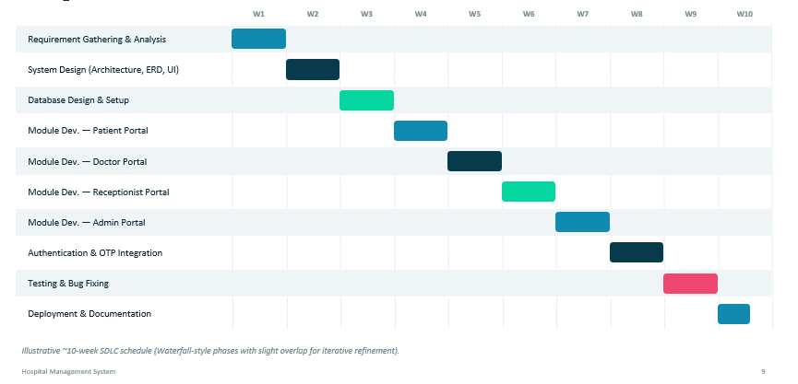

10. TARGETED USERS
1. Super Admin
Manages the overall system, users, doctors, hospital information, billing records, reports, and system activities, including switching two-step OTP login on or off.
2. Doctors
Use the system to manage appointments, view authorized patient information, record diagnoses, and create prescriptions.
3. Patients
Use the system to view appointments, doctor information, prescriptions, and available personal medical information.
4. Receptionists
Manage patient registration, appointments, doctor availability, and authorized front-desk activities.
5. Hospital Management
Uses reports and dashboards to monitor hospital operations and make administrative decisions.

11. REQUIREMENT DETERMINATION AND ANALYSIS
Requirement determination identifies what the hospital needs from the proposed system. The main focus is to reduce time-consuming manual processes and provide a single platform for role-based hospital management.
- Study the current hospital registration and appointment process.
- Identify delays caused by manual record searching and repeated data entry.
- Identify the information required by doctors, patients, receptionists, and administrators.
- Determine the data that must be stored in the database.
- Define role-based permissions and security requirements.
- Identify reports and dashboards required by hospital management.
- Analyze the system for usability, performance, reliability, and scalability.

12. REQUIREMENT DETERMINATION
The requirements are divided into functional and non-functional requirements.
Functional Requirements
- User registration and secure login.
- Role-based dashboard for Super Admin, Doctor, Patient, and Receptionist.
- Patient registration and profile management.
- Doctor profile and availability management.
- Appointment booking, updating, cancellation, and status tracking.
- Doctor access to authorized patient records.
- Prescription creation and management.
- Patient access to appointments and authorized medical information.
- Billing record management, including automatic bill creation at booking and no-show fee billing.
- Reports and dashboard information.
- Secure logout and session management.
- Super Admin control to enable or disable two-step OTP verification for all logins.
Non-Functional Requirements
- Usability: The interface should be simple and easy to understand.
- Performance: Common operations should respond quickly to reduce waiting time.
- Security: User accounts and medical information must be protected from unauthorized access.
- Reliability: The system should operate consistently and handle valid requests correctly.
- Scalability: The system should support future modules and increasing data.
- Maintainability: The code and database should be organized for easy updates.
- Compatibility: The web application should work on commonly used modern browsers.

13. REQUIREMENT SPECIFICATION
1. Hardware Requirements
- Computer/Laptop with a modern processor.
- Minimum 8 GB RAM.
- Minimum 10 GB available storage for project files and database.
- Keyboard and mouse.
- Display/monitor.
- Stable local network or Internet connection as required by deployment.
2. Software Requirements
- Operating System: Windows / Linux / macOS.
- Programming Language: Python.
- Web Framework: Django.
- Frontend: HTML, CSS, JavaScript, Bootstrap.
- Database: MySQL / SQLite.
- Development Environment: Visual Studio Code.
- Web Browser: Google Chrome, Microsoft Edge, or another modern browser.
- Version Control: Git/GitHub (optional).
3. Role-Based Functional Specification
Super Admin
The system shall provide Super Admin login. The Super Admin shall be able to manage doctors, receptionists, patients, user accounts, hospital information, billing records, and authorized system records, and shall be able to enable or disable two-step OTP verification for all logins.
Doctor
The system shall provide Doctor login. Doctors shall be able to view assigned appointments, access authorized patient records, add diagnosis/notes, and create prescriptions.
Patient
The system shall provide Patient login. Patients shall be able to view their profile, appointments, doctor information, prescriptions, and authorized medical information.
Receptionist
The system shall provide Receptionist login. Receptionists shall be able to register patients, manage appointments, check doctor availability, update authorized patient details, mark a missed appointment as a no-show with an automatic fee, and handle permitted billing operations.

14. SYSTEM DESIGN
The proposed system follows a role-based web application architecture. Users access the application through a browser. After login, the system identifies the user's role and redirects the user to the appropriate dashboard. The application layer processes requests and communicates with the database to store or retrieve information.

14.1 High-Level Architecture
User → Web Browser → Django Application → Authentication & Role Management → Business Modules → MySQL/SQLite Database

14.2 Main System Modules
- Authentication and Authorization
- Security Settings (Two-Step OTP Toggle)
- Super Admin Dashboard
- Doctor Dashboard
- Patient Dashboard
- Receptionist Dashboard
- Patient Management
- Doctor Management
- Appointment Management
- Medical Record Management
- Prescription Management
- Billing Management
- Reports and Dashboard

14.3 Main Database Entities
- User
- Doctor
- Patient
- Receptionist
- Appointment
- Medical Record
- Prescription
- Bill
- Department (if required)
- Hospital Settings / System Information (e.g., two-step OTP toggle)

15. USE CASE DIAGRAM
The Use Case Diagram represents how the four main actors interact with the Hospital Management System. The actors are Super Admin, Doctor, Patient, and Receptionist. Each actor receives access to functions according to their role.
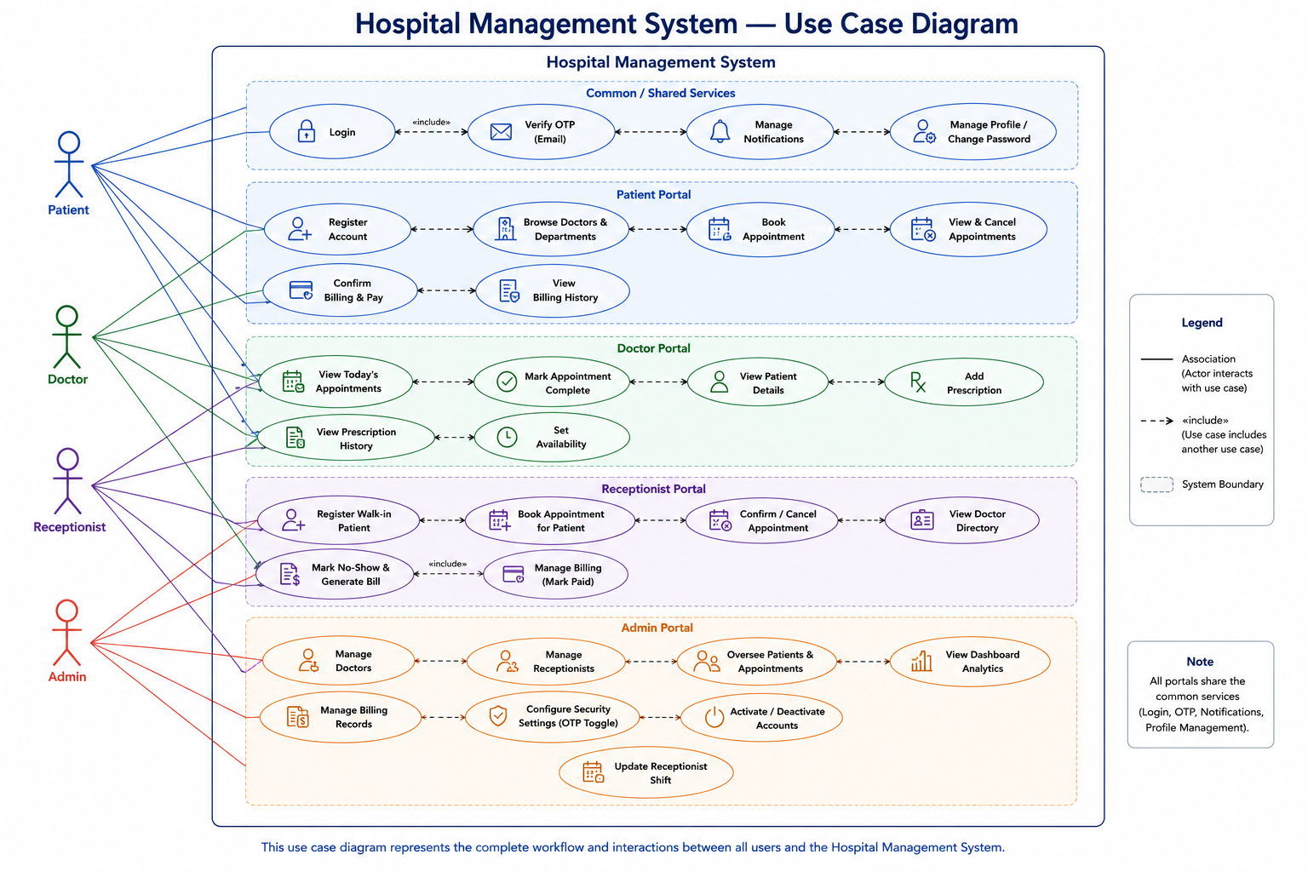

Figure 1: Use Case Diagram – Hospital Management System

Use Case Explanation
1. Super Admin
- Login securely to the system.
- Manage system users and their roles.
- Add, update, and manage doctors and receptionists.
- Manage system records and configurations.
- Manage and monitor billing activities.
- Enable or disable two-step OTP verification.
- View system reports and dashboard statistics.

2. Doctor
- Login securely to the system.
- View and manage appointments.
- View authorized patient information and medical records.
- Create and manage patient prescriptions.
- Add and update relevant patient medical information.

3. Patient
- Login securely to the system.
- View upcoming and previous appointments.
- View doctor information and details.
- View authorized prescriptions and medical records.
- View billing/payment information where permitted.

4. Receptionist
- Login securely to the system.
- Register and manage patient information.
- Book, update, and manage appointments.
- Check doctor availability and schedules.
- Mark appointments as No-Show when required.
- Perform permitted billing and payment-related activities.

